Invasive Plants

Activity Guide

In different parts of the country, there are plants that have learned to live in specific conditions, and some newer plants have arrived too. Native plants grow naturally in an area and help the environment by supporting other plants and animals. Invasive plants, however, don't belong and compete with native ones for things like space and nutrients.

NATIVE PLANTS INVASIVE PLANTS

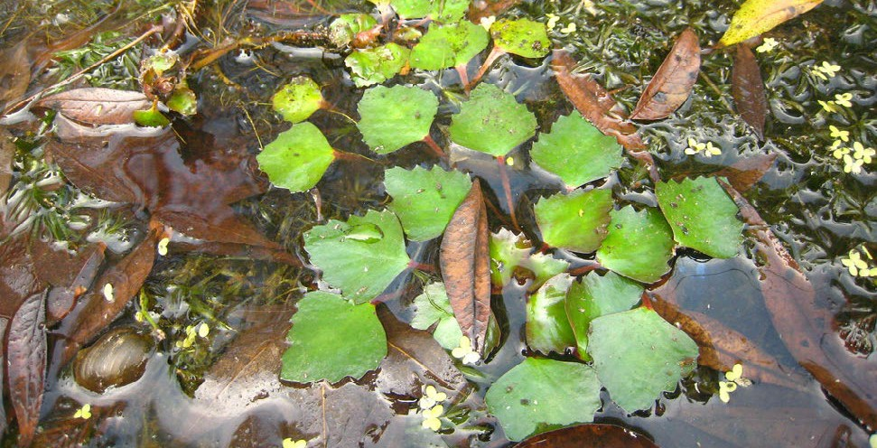
Blue Flag
Iris versicolor
Bennie Bengston, Lady Bird Johnson Wildflower Center

jennyhsu47: Flickr
Water Chestnut
Trapa natans L.

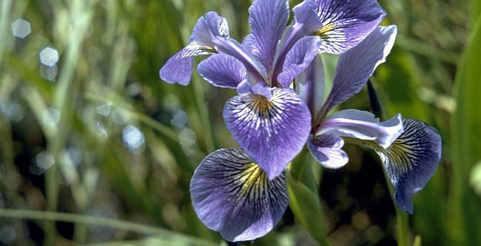
Found in northern midwest and northeast US states. It grows in wet meadows, marshy areas, and along river and lake shores. Pollinated by bumblebees, skipper butterflies, and moths.
Can reduce oxygen levels, increasing the potential for fish kills. It competes with native vegetation and is of little value to waterfowl. Water chestnut infestations limit boating, fishing, swimming and other recreational activities.

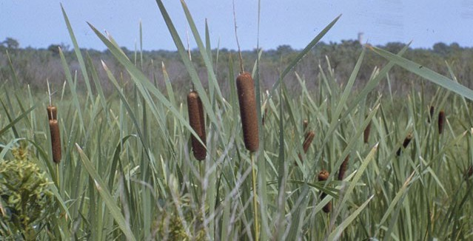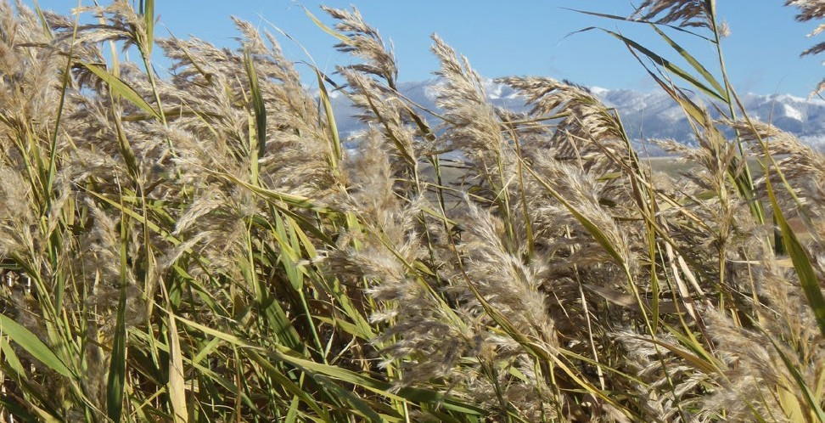

Albert F. W. Vick, Lady Bird Johnson Wildflower Center
Broad Leaved Cattail
Typha latifolia
Matt Lavin: Flickr
Phragmites
Phragmites australis

Forms dense stands in shallow water and provide nesting sites for red- winged blackbirds, ducks, geese and fish. Muskrats and beavers enjoy the shoots and roots, while teal ducks, finches and least bitterns eat the seeds.
Forms dense homogeneous stands that consume available growing space and push out other plants. It also alters wetland hydrology, increases potential for fire, and reduces and degrades wetland wildlife habitat due in part to its very dense growth habit.

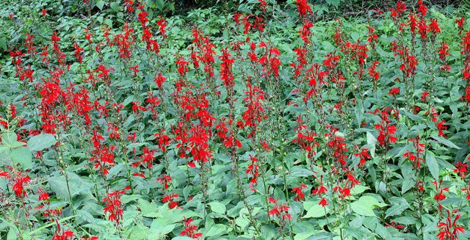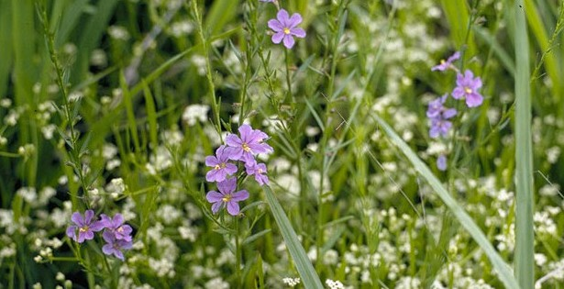

R. W. Smith, Lady Bird Johnson Wildflower Center
Cardinal Flower
Lobelia cardinalis

Bransford, W.D. and Dolphia, Lady Bird Johnson Wildflower Center
Purple Loosestrife
Lythrum salicaria

Depends on hummingbirds, which feed on the nectar, for pollination. Birds
and butterflies also eat the nectar.
Able to rapidly establish and replace native vegetation with a dense, homogeneous stand that reduces local biodiversity, endangers rare species and provides little value to wildlife.

*These plants are native to many regions of the US, but not all.

Learn more at NEEFusa.org With support from Spectrum Brands

Invasive Plants

Activity Guide

In different parts of the country, there are plants that have learned to live in specific conditions, and some newer plants have arrived too. Native plants grow naturally in an area and help the environment by supporting other plants and animals. Invasive plants, however, don't belong and compete with native ones for things like space and nutrients.

NATIVE PLANTS |  | INVASIVE PLANTS
Enter your text here |  | Enter your text here
Enter your text here |  | Enter your text here
Enter your text here |  | Enter your text here

