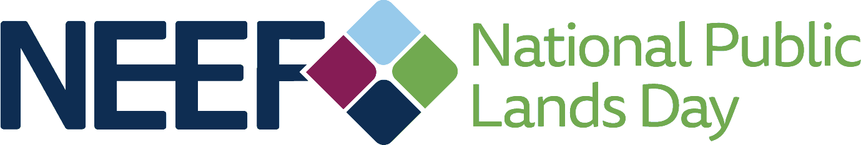

NPLD Local MediaAdvisory

Once you have your event details set, tap local media to help you spread the word. Create your media advisory and send it to your media contacts two weeks before your National Public Lands Day event. Update the advisory (include any changes to locations, the number of volunteers expected, planned activities, guest speakers, etc.) and send it again on the Monday before your event, and once again with final updates on the morning of the event.

Remember: Sending the advisory is only half of the job. Emails get buried, blocked, and forgotten all the time. Call major newspapers and TV stations on the Monday before your event to remind them of the event and ask if they plan to cover it. Do your research and target reporters who have covered National Public Lands Day or similar events in the past as well as the assignment editor. Travel writers, weekend editors, and environment writers are also good targets. Make a note of any reporters who say they plan to attend so you can make an effort to connect with them on site. It’s also a good idea to follow up with them after the event and confirm they have everything they need to file their story.

On the next page, you will find a template media advisory to tailor and use to promote your NPLD event. Check out the Media Outreach Calendar (accessible in the Site Manager Promotional Toolkit) for more media planning tips.

FOR IMMEDIATE RELEASE
Contact: (Your Name) (Phone/email)

MARK YOUR CALENDAR FOR NATIONAL PUBLIC LANDS DAY
Volunteers at {Insert name of site} to join volunteers nationwide for nation’s largest single-day volunteer effort for public lands.

On September 24, 2022, more than 150,000 volunteers across the country will join in trail maintenance and planting projects, trash pick-ups, and other activities aimed at restoring and caring for our public lands to celebrate the 29th annual National Public Lands Day (NPLD). Organized each year by the National Environmental Education Foundation (NEEF), and nationally sponsored by Toyota Motor North America, National Public Lands Day is the nation’s largest single-day volunteer effort for public lands.

(Your event description, include type of audience – adults, families, and the activities you will hold, work to be accomplished, local participants including schools or special guests.)

Who: (Name of your organization) What: (Name of your event) Where: (Physical address of event)
When: Saturday, September 24, 2022 (time)
Contact: (Event organizer phone number, email and website address)

About NPLD:
Over the last decade, over one million volunteers have donated nearly 5 million hours of their time for public lands on NPLD, worth an estimated $133 million.

Facts:
- NPLD is the nation’s largest single-day volunteer effort for public lands.
- It is one of only five fee-free day for all national parks as well as many state and local parks.
- NPLD events feature volunteer, education, health, and recreation activities.

Learn more about National Public Lands Day at NEEFUSA.org/NPLD. Everyone is encouraged to follow and participate in the conversation on social media using the hashtag #NPLD.
###

